**PHOTOGRAPH WORK**

Specific Objectives

By the end of the topic the learner should be able to:

(a) Identify types of photographs;

(b) Describe parts of a photograph;

(c) Estimate sizes of features appearing on photographs;

(d) Draw sketches from photographs;

(e) Identify and interpret features from photographs.

**Content**

1. Types of photographs.
2. Parts o f a photograph.
3. Interpretation of photographs by estimation of actual sizes of features, sketching from photographs, studying and describing natural and human features and activities on photographs.

**Definition**

Photograph

* A photograph is an image or a picture of an object recorded by a camera on a light sensitive film or paper.

Types of Photographs

* Classified according to the viewpoint from which they were taken.
* The classes are:

1. Ground photograph
2. Aerial photographs

Ground Photographs

* These are photographs taken from the ground with the camera held level to the object.
* The person taking the photographs stands in a position where he can see the object directly infront of him/her.
* Objects far away from the camera are not a;ways shown.
* The objects near the camera appear big and clear.
* An area hidden from the eye of the camera by an object is called **the dead ground**.
* Ground photographs are further classified into:
* Ground general view.
* Ground close up (particular view).
* Ground obliques

Ground Close-up

* The camera is focused on one major object,such as an animal,a crop or a car.
* This object may block out the other things behind it.
* Close ups are the most common types of photographs.





**Ground close-up photographs**

Ground General View Photographs

* These photographs are taken with the camera held horizontal to the ground facing the area focused on.
* The objects in the photograph become progressively smaller as the distance from the camera incrases.

**Examples**

1. Identify the activity on the photograph below pastoralism
2. Name he type of photograph above ground general view

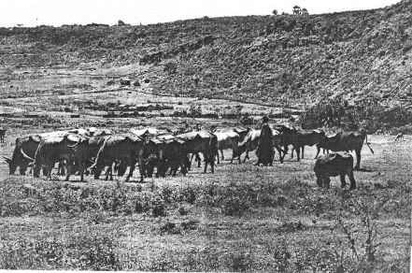

1. Draw a rectangle representation of the photograph

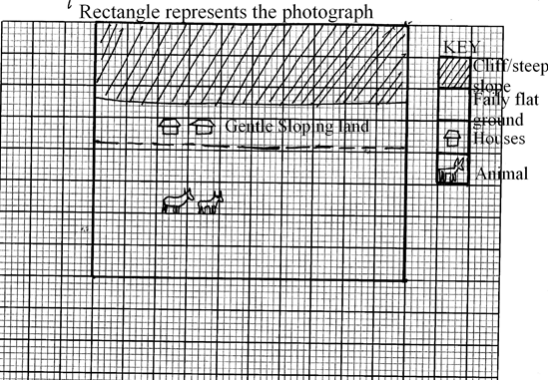

**Example**

Study the photograph below and use it to answer question (a)

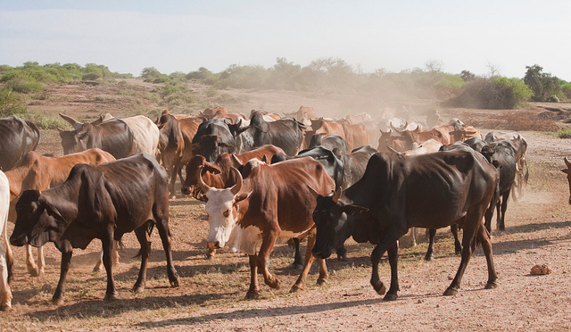

1. (i) Name the type of photograph shown above (1 mark)

* *Ground general view*

(ii) What time of the day was the photograph taken if the camera was held facing south? (1mark)

* *Evening*

(iii) Draw a rectangle measuring 16cm by 9cm to represent the area of the photograph. On it sketch and label the main features shown on the photograph (5 marks)

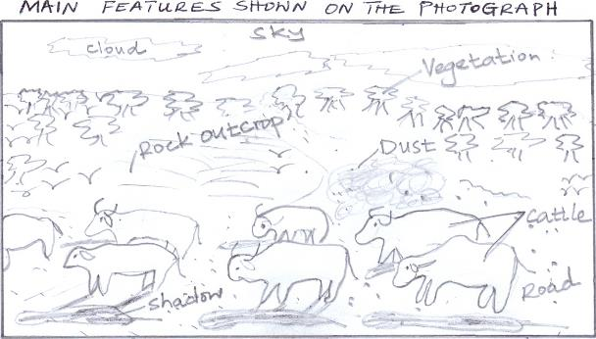

(iv) Describe the landscape of the area represented by the photograph. (3marks)

* *The land rises from the foreground towards the background*
* *The area covered with vegetation is slightly raised.*
* *The area in the background has bare rock surfaces/rock outcrops.*
* *The area in the foreground is gently sloping*

Ground oblique

* This is taken while the photographer is standing on higher ground than the object.
* The camera is tilted downwards towards the object.
* Since it this photograph is taken from a raised point it tends to clearly bring out more details of features such as valleys and slopes.

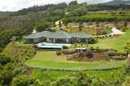

**A ground oblique photographs**

Aerial Photographs

* Photographs taken from the air using aircrafts,ballons,parachutes and sometimes satellites.

Types

1. **Vertical aerial photographs**
2. **Oblique aerial photographs.**

**Vertical Aerial Photograph**

* These photographs are taken from vertically above as illustrated in figure 3.5. The camera lense focuses vertically on the area to be photographed.
* As a result, only the tops of features like hills, trees and buildings can be seen as shown in below.
* These types of photographs are used for making maps.

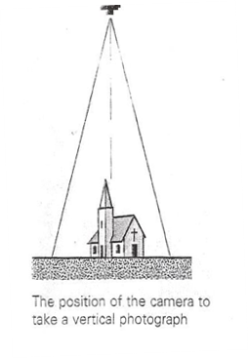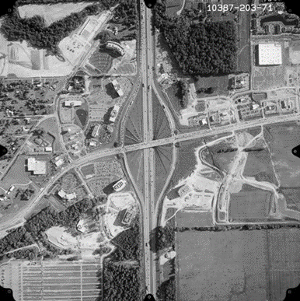

**Oblique Aerial Photograph**

* These are photographs taken from a low flying aircraft with the camera tilted at an angle and cover a relatively large area as shown in below.
* The objects nearer the camera are larger than those far away. Although these photographs are similar to ground obliques, they cover large areas and the features on them appear smaller and more obscure.

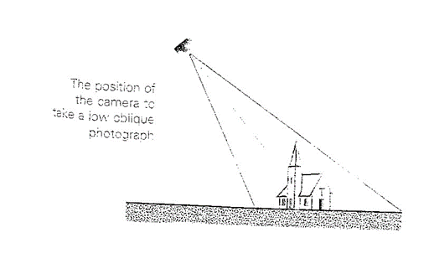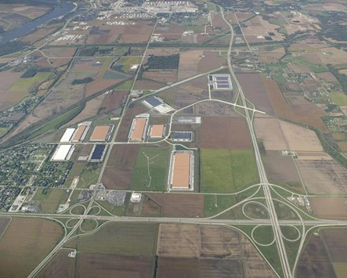

Parts of photograph

* For the purpose of location and interpretation of features, a photograph is divided into three main parts namely:
  1. **Foreground:**This is the part nearest to the camera.
  2. **Middleground:**This is the part in the centre of the photograph.
  3. **Background:**This the part farthest from the camera.

Each of these parts is sub-divided into left, middle and right as indicated in below.

|  |  |  |
| --- | --- | --- |
| Left Background | Middle Background | Right Background |
| Left middle ground | Middle Middle ground | Right Middle ground |
| Left foreground | Middle Foreground | Right Foreground |

Position of the camera.

Interpretation of Photographs

**Estimating Actual sizes of Features on photographs**

* Height of objects can be estimated by the use of other familiar objects shown in the photograph. For example, the height of a crop like tea can be estimated using a familiar object like an adult human being standing where the crop is growing.
* It is, however, not possible to accurately determine sizes of unfamiliar objects shown in a photograph.
* In photographs, images grow progressively smaller from the focal point outward, that is, from the foreground to the background.

**Drawing a Sketch from a photograph**

* To draw a sketch from a photograph, the following steps should be followed:

1. Draw a rectangular or square frame preferably of the same size as the photograph.
2. Identify the required features and plot them in the frame appropriately. Use clear simple lines and avoid unnecessary shading.
3. Label the required features and give your sketch a title. Interpretation of Physical

Features and Human Activities on a Photograph

* To interpret a photograph, it is important to study it in an orderly manner starting from the foreground through the middle of the background and then left to right.
* A photograph usually has different aspects of physical features such as hills, valleys, vegetation and drainage features as well as human-made features such as farms, bridges, roads and houses.

Relief

* Major relief features which can be deduced from a photograph include the slope, hills, plains, plateaus, ranges, escarpments and valleys.
* Several clues can be used to describe the relief of a given area in the photograph. These clues include:

1. Hilly landscapes may be a likely indication of a highland area, while dissected landscape in a hilly area indicates that the place has undergone heavy erosion. Undulating or gently rolling landscape, on the other hand may indicate that the area has undergone little or minimal erosion or may be used as an evidence to show that the landscape is young of recent origin.
2. The shape of hills can also give clues to the formation and age of such hills with smooth tops are a likely indication of young volcanic hills, which have been least affected by erosion. Rugged hills with protruding rock pillars, toes or plugs may indicate that the hills ate old and have been heavily affected by erosion.
3. The human activities taking place in a photograph can also give clues to the nature of the landscape. For instance, presence of irrigation activities may suggest that the area shown in the photograph is a plain or is a gently sloping. Terraced landscape, on the other hand, indicates that the area represented in the photograph is steep and therefore vulnerable to erosion. Terracing is therefore meant to reduce or control soul erosion. Particular crops in a photograph can also suggest the relief of a place. For example, crops like tea indicate that the area covered in the photograph is a highland while presence of coconut plantations is evidence that the photograph represents a coastal area. Different human-made features in the farms can also give clues to the relief represented in a photograph. For instance, combine harvesters in a farm are likely indication of a plain or gently rolling terrain.
4. The type of drainage in a photograph can also provide a clue as to the nature of relief in an area. For instance, the presence of swamps may suggest that the area is flat and hence waterlogged. A lake on top of a hill is a likely indication of a crater lake and can hence also be used as a clue to show that there has been volcanic activity in the area. Long narrow lakes with a valley stretch running parallel to the hills or ranges in the adjacent vicinity are likely indications of faulting. Different forms of communication lines can be used to interpret the landscape. For instance, a road between two hills can be an indication that the hilly area is characterized by passes. A winding railway is an indication of a rugged landscape.
5. Vegetation types shown in a photograph can also be used as a clue. In the tropics, cone-shaped trees with thin leaves can be used as evidence to show that the photograph represents a highland area.

Drainage

* The common drainage features that may appear on photographs include rivers, lakes, oceans, swamps, ponds, wells, boreholes and irrigation channels. On a photograph, water surfaces generally appear brighter than the surrounding features like vegetation and can easily be identified.
* When interpreting drainage, the following guidelines may be used:

1. Rapids and waterfalls would indicate a river that is flowing through a hilly landscape or is in its youthfull stage.
2. Meanders indicate the middle stage of a river as the river enters less steep land or almost flat land. Some of the meanders may be cut-off from the main river and from ox-bow lakes (ox-bow lakes appear crescent shaped). The presence of a flood plain in a photograph is an indication that the river is in the old stage. The presence of a delta may be identified by the river breaking into many channels before entering the sea.

Major rivers are joined by the tributaries. The main stream and all its tributaries form a river or drainage system. On some aerial photographs (especially those taken from near the ground surface), one may notice that drainage systems form different patterns on the surface. These depend on the general structure of that surface.

If part of a river is included in a photograph, one may determine the direction of flow by looking at the general relief. Rivers flow from higher ground (source) to lower ground.

Vegetation

* To describe the vegetation type from a given photograph, the following aspects need to be taken into account:

1. The type of vegetation: It is made of trees, grass, shrubs, swamps or thicket?
2. The height and shape of vegetation, that is:Are the trees tall, short, cine shaped, umbrella shaped? Are the leaves broad, needle shaped or thorny? Are the stems bulky?
3. Density of vegetation, that is: Are the trees close together or scattered? Is there any undergrowth?
4. Vegetation species that is i.e: It is one type of vegetation? Are the trees of the same species? Is it possible to name or identify some vegetation species? Is the vegetation planted by human beings or natural?

Using the information gathered from a photograph, it is possible to identify different vegetation types such as tropical rainforest grasslands, woodland vegetation, scrubs and desert vegetation. It is also possible to differentiate between natural and planted vegetation. Planted vegetation usually appear in rows (patterns) with little undergrowth and have the same tree species of similar heights.

Climate

* Different aspects of climate may be deduced from a photograph in the following ways:

1. Temperatures

These can be deduced from the kind of agricultural activities practiced in the areas shown by the photograph. For example, the presence of sugarcane plantations would suggest high temperatures while the presence of tea and dairy farms would suggest cool and temperatures. The manner in which the people in the photograph are dressed can also be used to describe the temperature experienced in an area. For example, people in a hot place will wear light cloths while those in cold areas will dress warmly.

1. Rainfall

Rainfall amount received in an area can be deduced from the kind of agricultural activities practiced. For example, dairy farming and the growing of crops like tea and coffee would generally suggest that in the area where they ate grown is likely to have sufficient and reliable rainfall which is evenly distributed while short scrub or Bush land may be an indication of insufficient rainfall.

Human-made Features

A wide range of human-made features may be recorded in photographs. These may include:

1. Settlement

Thus is shown in photographs by houses. The houses may be arranged in different ways to give settlement patterns. Fir example they may be grouped together to form nucleated patterns. Settlement is indicated by the presence of people, population distribution and density. Other indicators of settlement include social facilities such as schools, churches, health centers and playgrounds.

1. Agricultural Activities

These include both crop farming and cattle rearing. Crop farming is indicated by crops seem in the photograph, people preparing land fir crop planning, weeding or harvesting. Cattle rearing is indicated by the animals shown in the photograph, vast grazing land, cattle dips and ponds.

It is important to note the factors that favor an agricultural activity and the evidence fir each factor. These factors include:

* High rainfall.
* Gentle topography.
* Availability of water for irrigation.
* Good transport network.
* Availability of markets.
* Availability of labour.

Livestock keeping may be favoured by availability of vast grazing lands

1. Planted Forests

Planted forests are common in photographs. They may be identified by their appearance. They are of similar height, species and appear in rows.

1. Fishing

Fishing is indicated by fishing vessels, people casting nets and fish traps.

1. Mining

This is indicates by a mine or quarry, people undertaking a mining activity or a mineral processing factory.

1. Manufacturing

Thus is indicated by factory buildings with large chimneys or people engaged in a processing activity like jua kali artisans.

End of topic

|  |
| --- |
| Did you understand everything?  If not ask a teacher, friends or anybody and make sure you understand before going to sleep! |

Past KCSE Questions on the topic

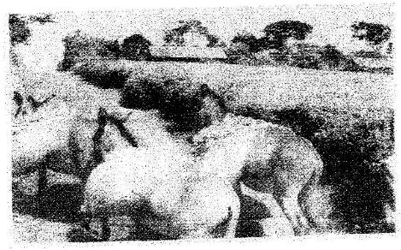1. The photograph provided shows a tea growing area in Kenya. Use it to answer questions (a) and (b)

a) (i) What evidence in the photograph shows that this is a ground

general-view type of photograph? (2mks)

(ii) Draw a rectangle measuring 15cm by 10cm to represent the area of the photograph. On it sketch and label the main features shown on the photograph. (5mks)

(iii) Identify two features from the photograph that show that this is a small scale tea farm. (2mks)

b) Describe the stages involved in the cultivation of tea from land preparation to the stage shown on the photograph.

1. (i) Name two districts in the Eastern province where tea is grown.

(2mks)

(ii) Explain four ways in which the Kenya Tea development agency (KTDA) assists small scale tea farmers in Kenya (8mks)

2. What is the type of photograph shown?

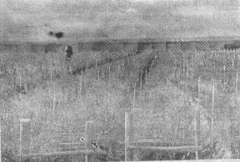

3. Name each of the following:

(i) Crop under cultivation (2mks)

(ii) Type of farming (2mks)

(iii) Other groups of crops in this type of farming. (2mks)

(iv) The province in Kenya where this photograph was taken. (2mks)

4. Name five problems facing this type of farming in Kenya. 5mks

5. Name two major export destinations (countries) for farm produce shown. (2mks)

6. Name three physical features at the background of the photograph. (3mks)

7. Draw a rectangle of 12cm by 7cm to represent the area covered by the photograph.

